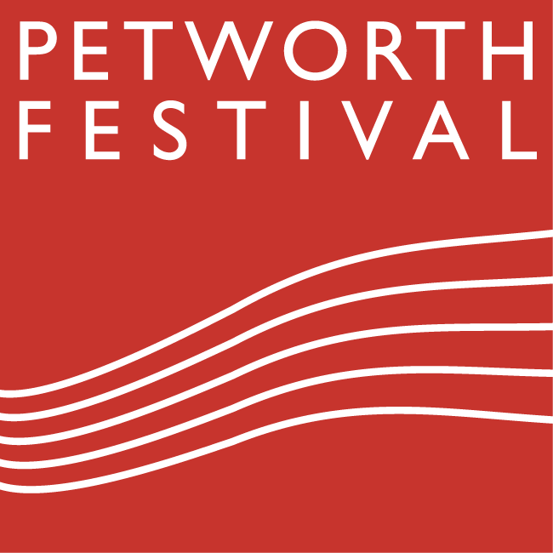**GIFT AID FORM Registered charity number 1113784**

It is always difficult to finance the Petworth Festival, owing to the size of the delightful venues and the nature of the events. Over the last few years, direct income from Festival events has covered less than half the cost. The balance has come from sponsorship, grants and gifts.

**Donating through Gift Aid means charities like ours can claim an extra 25p from HMRC for every £1 you give**

**Festival Patrons:** give £100 or more each year, are invited to exclusive parties and receive a 5% discount on tickets bought during the Patrons’ priority booking period, which is longer than that of ‘Friends’.

**Festival Friends:** give £30 or more each year, are invited to exclusive parties and receive a 5% discount on tickets bought during the Friends’ priority booking period.

**I would like to make a donation of £ ………………………… *You can make a donation directly online:*** [***www.petworthfestival.org.uk***](http://www.petworthfestival.org.uk)*. Follow the links to ‘how to support’ where you can choose to become a ‘Friend’, a ‘Patron’ or simply make a donation of your choice. Alternatively, you might like to set up a standing order payment. If you would like to do this please complete the form below.*

Please treat any donations I make in the future or have made in the past 5 years to Petworth Festival as Gift Aid donations. I am a UK taxpayer and understand that if I pay less Income Tax and/or Capital gains Tax than the amount of Gift Aid claimed on all my donations in that tax year it is my responsibility to pay any difference. If you pay Income Tax at the higher or additional rate and you want to receive the additional tax relief due to you, you must include all your Gift Aid donations on your Self-Assessment tax return, or ask HM Revenue & Customs to adjust your tax code**.**

**Name(s)....................................................................................................................................................**

**Address.....................................................................................................................................................**

**...................................................................................... Postcode .........................................................**

**Tel No ........................................……..... Email .…………………………............................................**

**Signature ………………………………………….. Date ………..……………….............................**

Please notify Petworth Festival if you want to cancel this Gift Aid declaration, change your name or home address or no longer pay sufficient tax on your income and/or capital gains.

**NB: PETWORTH FESTIVAL HOLDS AND USES ALL PERSONAL INFORMATION EXCLUSIVELY FOR ITS OWN PURPOSE IN COMPLIANCE WITH GDPR. IF YOU DO NOT WISH TO RECEIVE E-BULLETINS PLEASE TICK HERE (YOU CAN ALSO UNSUBSCRIBE VIA THE LINK ON THE E-BULLETIN AT ANY TIME)**

**□ I DO NOT WISH TO RECEIVE E-BULLETINS**

.............................................................................................................................................................................................................

**STANDING ORDER TO BANKER**

**To..........................................................................Bank PLC Sort Code.............................……………...….....**

**Bank Address ........................................................................................................................………..…...….......**

**....................................................................................................Postcode ............................…………….…........**

**Please pay** …................................. **every** ........................... (year/month) **starting** ..........................................

to **Petworth Festival** Account No. **50327526** **National Westminster Bank PLC**

**Petworth branch** Sort Code **60-16-27** **until**......................................(further notice OR date of last payment)

**My account name**.............................…....................... **My account number** ........………………………..........….................

**Signed**................................................................................ **Date …………….**..........................................................................................

**PLEASE RETURN THIS ENTIRE FORM TO PETWORTH FESTIVAL**

FAO Melody Jones, Festival Administrator, melody@petworthfestival.org.uk

3 Market Square PETWORTH GU28 0AH.